**What is Microsoft PowerApps?**

**PowerApps** is a suite of apps, services, connectors and data platform that provides a rapid application development environment to build custom apps for your business needs. Further, apps built using

**PowerApps** have a responsive design, and can run seamlessly in browser or on mobile devices (phone or tablet).

It’s a Software as a Service (SaaS) solution that allows companies to build business apps quickly and efficiently.

**PowerApps Plan 2 free trial**

Users can try **PowerApps** Plan 2 for **free** for 30 days. During the trial, users have access to all of the features in **PowerApps** Plan 2. ... Users who have access to **PowerApps** or **Microsoft** Flow through Office 365 or Dynamics 365 apps and plans can still access **PowerApps** or **Microsoft** Flow

Create free account here :

<https://make.powerapps.com/>

**Features of PowerApps**

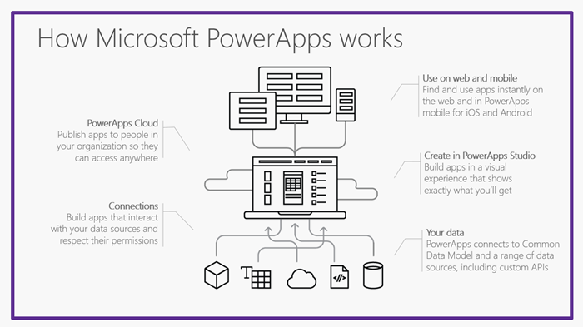

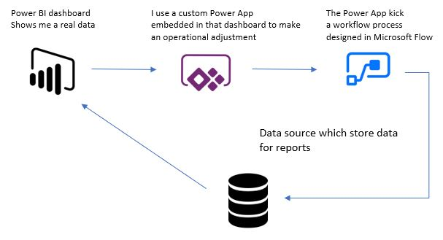

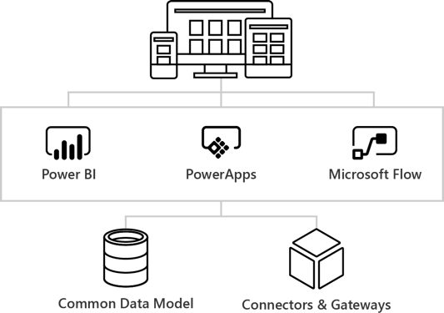

**Day 01: Hands-on**

Create a Project to store and manage employee details such as name, emailed, mobile number, salary, country, dob etc.

We will create CRUD application

C- Create

R-Read

U-Update

D-Delete

Along with some other functionality:

S- Search

SO-Sorting

And other customization like title , color change etc.

**There are following steps :**

Example 1: Mange the Employee Details in excel

Attributes: EID NAME EMAIL PHONENO SALARY COUNTRY

10 Raman raman@gmail.com

Step 1: Connection data store (excel, sql, azure cloud etc.)

Create excel file and keep sample data

Step 2: Upload the worksheet in cloud (google drive, onedrive, azure, etc..)

Step 3: Login to powerapp portal

Step 4: Select app from data connection